**WARNING: If you see the message below ALWAYS CLICK CANCEL**

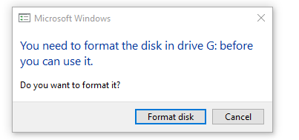

Backup Creation

1. Insert SD Card
2. Launch Win32 Disk Imager

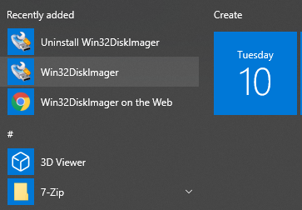

1. Select the file path in which the backup will be stored.

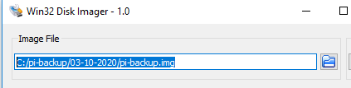

1. Select the drive letter for the SD Card

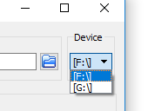

1. Click “Read”



1. Wait for the backup to complete
2. Remove SD Card

Restoring a Backup

1. Insert SD Card
2. Launch Win32 Disk Imager



1. Select the file path from which the backup will be restored



1. Select the drive letter for the SD Card



1. Click “Write”



1. Wait for the restore to complete
2. Remove SD Card

For more information go to <https://raspberrypihq.com/how-to-backup-your-raspberry-pi/>